**SOP Replication Issue Resolution**

# Project: TMO_DBA (MS) Database Administration

## Introduction

The purpose of this document is to outline the steps necessary to verify and resolve some of the replication issues the ADM Database Administration – SQL team have been presented with.

There are three alert types that are sent to the ASM Database Administration – SQL Distribution List:

* Blocking
* Long running query
* Query timeout

These alerts may come from either the Foglight monitoring tool, or from the PSQLOPS05\DISTRO2 SQL Server. An example of the blocking alert from Foglight is below:

Foglight Cartridge for SQL Server has generated a Warning alarm for instance RPDB2 on host PSQLRPT16.

|  |  |
| --- | --- |
| Alarm: | DBSS - Long Lock Running |
| Severity: | Warning |
| Message: | Long Lock Running. At least one process has been blocked for more than 900.00 seconds. Session: "164", User: "GSM1900\SQL_PRD_REPL_DIS5", Host: "PRDPWSQLD001C", Program: "PSQLDWH11\NDW_PerfMgmt_Reporting_PerfMgmt_Reporti" has blocked the following sessions: -> Session: "395", Host: "PRDPWSQLD001C", Program: "PSQLDWH11\NDW_PerfMgmt_Reporting_PerfMgmt_Reporti", Database: "PerfMgmt_Reporting" for "1799" seconds. |
| Created on: | Wed Oct 25 12:16:03 PDT 2017 |

For further information [click here](http://prddsmwmn003.gsm1900.org:8080/console/task/showAlarm?alarmId=/alarms/175f998f-7fd8-400a-bec2-ff0c59abe241)

Generated by Foglight Cartridge for SQL Server (agent: PSQLRPT16-RPDB2).

## Resolution Steps for blocking, long running queries, or query timeouts by the Replication Distribution Agent.

1. Using the alert example above, connect to PSQLRPT16\RPDB2 to determine if there is blocking by executing the following SQL:

SELECT *

FROM sys.sysprocesses

WHERE Blocked <> 0

1. Chances are more than likely, you will find that that the GSM1900\SQL_PRD_REPL_DIS5 account is causing the blocking. This account seems to “fall asleep” without releasing its lock on an object.
2. In this case, the source is coming from PSQLDWH11\NDW. Connect to the server and right-click on Replication to launch the Replication Monitor as shown below:

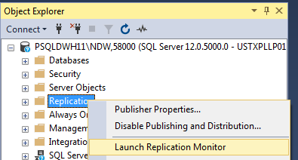

1. Once in Replication Monitor, you will be see all of the subscriptions in the left-hand pane.

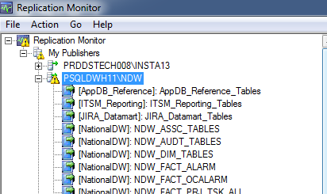

1. Double-Click on the subscription that is having the blocking issue. In this case, it’s the Performance Management Reporting



1. You will then see the agents for the subscription(s) in question in the main, or right-hand pane

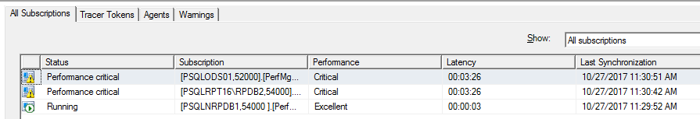

1. By double-clicking on the subscription in question, you will then have access to the agents for that subscription. In this case, you can see the PSQLRPT16\RPDB2 subscription. From the Action menu, you will see “Stop Distribution” as shown here:

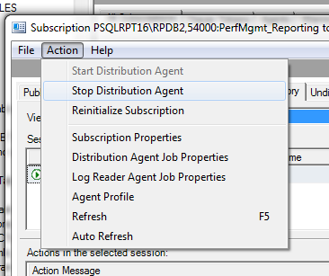

Stop the distribution agent,

1. Return back to PSQLRPT16\RPDB2, and execute the SQL query shown in step 1 above. You should see that the blocking has dissipated.
2. Once you’ve determined that the blocking has dissipated, return to the replication monitor, and start the distribution agent once again.
3. If this does not resolve the issue, also determine whether the Log and/or Queue Reader agents are running by returning to the previous menu within the Replication Monitor, and choosing the “Agents” tab as shown below:

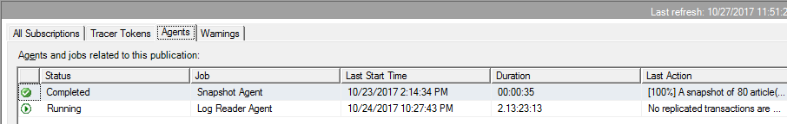

1. If the Log Reader is not running, double-click on it, and you will once again be brought to a menu similar to the one shown in Step 7 above. Choose the Action Menu, and start the agent.

## Resolution Steps for blocking, long running queries, or query timeouts by an Application Service Account

A long running query or blockage alert caused by an Application Service Account may be similar to the alert shown here

Foglight Cartridge for SQL Server has generated a Warning alarm for instance HSO08 on host PRDDSHSOX008.

|  |  |
| --- | --- |
| Alarm: | DBSS - Long Lock Running |
| Severity: | Warning |
| Message: | Long Lock Running. At least one process has been blocked for more than 900.00 seconds. Session: "129", User: "tibco", Host: "prdensp018", Program: "" has blocked the following sessions: -> Session: "69", Host: "prdensp112", Program: "", Database: "HandSetOrder" for "29601" seconds. Session: "54", User: "tibco", Host: "prdensp013", Program: "" has blocked the following sessions: -> Session: "70", Host: "prdensp025", Program: "", Database: "HandSetOrder" for "29621" seconds. |
| Created on: | Thu Oct 26 11:09:33 PDT 2017 |

For further information [click here](http://prddsmwmn003.gsm1900.org:8080/console/task/showAlarm?alarmId=/alarms/a0c006ce-2b44-4b6c-9077-3c67a81ffb61)

Generated by Foglight Cartridge for SQL Server (agent: PRDDSHSOX008-HSO08).

1. Connect to the target server in question in SQL Server Management Studio. In this case it’s prdensp112.
2. Execute the following SQL:

SELECT *

FROM sys.sysprocesses

WHERE Blocked <> 0

1. If blocking does exist as clarified in the alert, contact the Application Support SME as found for the server in question in MERLIN, and notify them of the blockage. Request permission to kill the SID.

## Failures due to duplicate or missing values at the Subscriber.

Replication can fail due to duplicate or missing values at the subscriber. The error message received would appear like the one shown below:

DATE/TIME: 10/30/2017 12:26:18 PM

DESCRIPTION: Replication-Replication Distribution Subsystem: agent PSQLDWH11\NDW-NationalDW-NDW_DIM_TABLES-PSQLNRPDB1,54000 -47 failed. The row was not found at the Subscriber when applying the replicated UPDATE command for Table '[dbo].[dim_workorder]' with Primary Key(s): [workorder_dwkey] = 2964201

COMMENT: (None)

JOB RUN: (None)

In this case, a row cannot be updated at the subscriber, because replication can’t find it there. The resolution to issues of this type are as follows:

1. Connect to the Replication Publisher in SSMS. In this case as you can see from the error above, it’s \\PSQLDWH11\NDW.
2. As in previous instructions above, Launch Replication Monitor.
3. Find the Replication scheme in question, and click on it.
4. As in previous instructions above, when you click on the Replication scheme in the left-hand pane, the replication agents will be populated in the right-hand or main pane as shown here:

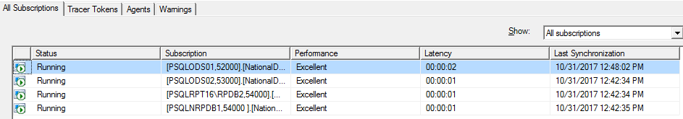

1. Double-click on the agent in question. In this case, it’s the one that’s highlighted in blue as shown above.
2. If you click on the error row, you will see information regarding the error as shown here. Not the error number:

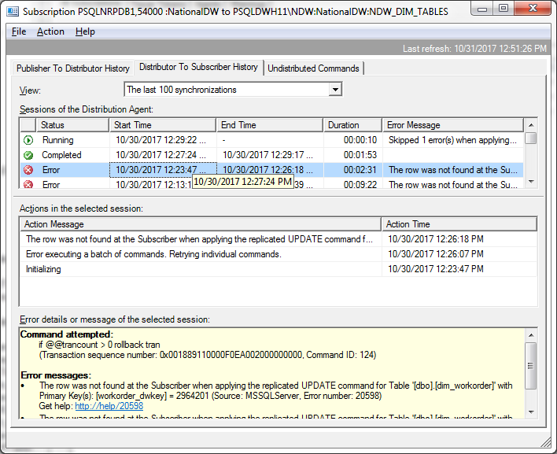

1. If you wish, you can connect to the both the source, and target machine/database in SSMS. Execute the following SQL to confirm that the error is valid:

SELECT *columnName*

FROM *tableName* (NOLOCK)

WHERE *columnName = missing/duplicateValue*

In this case, it was

SELECT workorder_dwkey

FROM dim_workorder (NOLOCK)

WHERE workorder_dwkey = 2964201

You should receive a NULL result set from the target/subscriber.

1. Connect to the Replication Distribution Server in SSMS, and find the SQL Agent Job associated with the Replication Scheme. In this case the server is \\PSQLOPS05\DISTRO2, and the job is called “PSQLDWH11\NDW-NationalDW-NDW_DIM_TABLES-PSQLNRPDB1,54000 -47”
2. Open the job, and choose the “Steps” tab.
3. Open the second step in the job called “Run Agent.” The command should be something similar to the following:

-Subscriber [PSQLNRPDB1,54000 ] -SubscriberDB [NationalDW] -Publisher [PSQLDWH11\NDW] -Distributor [PSQLOPS05\DISTRO2] -DistributorSecurityMode 1 -Publication [NDW_DIM_TABLES] -PublisherDB [NationalDW] -Continuous -Output C:\Temp\OUTPUTFILE_dim.txt -Outputverboselevel 2

1. If a “-SkipErrors” parameter already exists in the command list, merely append the error number with a preceeding comma. In this case there was no “-SkipErrors” parameter, so one needs to be added before the “-Output” parameter as shown below:

Subscriber [PSQLNRPDB1,54000 ] -SubscriberDB [NationalDW] -Publisher [PSQLDWH11\NDW] -Distributor [PSQLOPS05\DISTRO2] -DistributorSecurityMode 1 -Publication [NDW_DIM_TABLES] -PublisherDB [NationalDW] -Continuous -SkipErrors 20598 -Output C:\Temp\OUTPUTFILE_dim.txt -Outputverboselevel 2

As you can see, this is where the error number from the Replication Agent error details is important.

1. Once this parameter has been added to the distribution job, stop and restart the job. Replication will continue skipping all errors of the type found in the error details in Replication Monitor.
2. Notify the Application Owner/SME that the issue occurred, and please make sure that you provide the offending row’s details.

## Questions

If there are any questions regarding these instructions, please contact a TechM SQL Technical Lead for further information.